**RUN CHARTS:**

**A SIMPLE AND POWERFUL TOOL FOR PROCESS IMPROVEMENT**

The run chart is a powerful, simple and easy-to-use process improvement tool. Often, the run chart is shortchanged as the statistical tests that can be used with run charts are overlooked. This article takes the reader through the benefits of a run chart as well as how to correctly create and analyze one.

A process is defined as a series of activities that transforms a set of inputs into a specific set of outputs. Process change happens over time. Determining if a change has happened – and if that change lasts over time – is important to process improvement. A run chart is used to determine whether or not the central tendency of a process is changing. It does not require tedious calculations or special software to produce. It plots observed values on the y-axis and the times they were observed on the x-axis. The terms *time-series chart* and *run chart* are used interchangeably. Run charts are similar in some regards to the [control charts](https://www.isixsigma.com/tools-templates/control-charts/) used in statistical process control, but do not show the control limits of the process. They are, therefore, simpler to produce but do not allow for the full range of analytic techniques supported by control charts.

A run chart may be used to study observed data for trends or patterns over a specified period of time and focus attention on vital changes in the process. The run chart is useful for tracking information and predicting trends or patterns. It can determine if a process has common cause or special cause variation. It can also reveal whether a process is stable by looking for a consistent central tendency, [variation](https://www.isixsigma.com/tools-templates/variation/) and randomness of pattern. This is important because processes fall into one of four states:

1. Ideal
2. Threshold
3. Brink of chaos
4. State of chaos

When a process operates in the *ideal*state, the process has proven stability and target performance over time. This process is predictable and its output meets customer expectations. A process that is in the *threshold*state is predictable; however, it does not consistently meet customer needs. The *brink-of-chaos*state reflects a process that is unpredictable, but the outputs of the process still meet customer requirements. This process can produce nonconformance at any moment – it is only a matter of time. The fourth process state is the state of *chaos*, which produces unpredictable levels of nonconformance.

**How to Create a Run Chart**

There are seven steps to creating a run chart.

1. Decide on the measure to be analyzed (assuming there is a reliable measurement system in place).
2. Gather the data – have a minimum of 10 data points.
3. Draw a graph with a vertical line and a horizontal line.
4. On the vertical line, or the y-axis, draw the scale relative to the variable you are measuring.
5. On the horizontal line, or the x-axis, draw the time or sequence scale.
6. Calculate the mean/median (whichever the data set indicates to be appropriate) and draw a horizontal line at that value – going across the graph.
7. Plot the data in the sequence, or the time order, in which the data was collected.

**How to Interpret a Run Chart**

First look for runs. A *run* is a sequence of consecutive points which all lie on the same side of the mean/median line. Mean or [median](https://www.isixsigma.com/tools-templates/hypothesis-testing/understanding-uses-moods-median-test/) can be used depending upon the data. If the data is symmetrical, use mean; otherwise median is a better choice. A run can be a single point if both the previous and subsequent points are on the opposite side of the mean/median line. Ignore points that lie exactly on the line. Simply count the number of runs. Having more or fewer runs than expected indicates that there is non-random variation in the process (i.e., special cause). (See table below.)

|  |  |  |
| --- | --- | --- |
| **Expected Number of Runs Above or Below the Mean/Median4** | | |
| **Number of Data Points** | **Lower Limit # of Runs** | **Upper Limit # of Runs** |
| 10 | 3 | 8 |
| 11 | 3 | 9 |
| 12 | 3 | 10 |
| 13 | 4 | 10 |
| 14 | 4 | 11 |
| 15 | 4 | 12 |
| 16 | 5 | 12 |
| 17 | 5 | 13 |
| 18 | 6 | 13 |
| 19 | 6 | 17 |
| 20 | 6 | 15 |
| 21 | 7 | 15 |
| 22 | 7 | 16 |
| 23 | 8 | 16 |
| 24 | 8 | 17 |
| 25 | 9 | 17 |
| 26 | 9 | 18 |
| 27 | 9 | 19 |
| 28 | 10 | 20 |
| 29 | 10 | 20 |
| 30 | 11 | 21 |
| 31 | 11 | 22 |
| 32 | 11 | 22 |
| 33 | 11 | 23 |
| 34 | 12 | 23 |
| 35 | 13 | 24 |
| 36 | 13 | 25 |
| 37 | 13 | 25 |
| 38 | 14 | 26 |
| 39 | 14 | 26 |
| 40 | 15 | 26 |
| 41 | 16 | 26 |
| 42 | 16 | 27 |
| 43 | 17 | 27 |
| 44 | 17 | 28 |
| 45 | 17 | 29 |
| 46 | 17 | 30 |
| 47 | 18 | 30 |
| 48 | 18 | 31 |
| 49 | 19 | 31 |
| 50 | 19 | 32 |
| 60 | 24 | 37 |
| 70 | 28 | 43 |
| 80 | 33 | 48 |
| 90 | 37 | 54 |
| 100 | 42 | 59 |
| 110 | 46 | 65 |
| 120 | 51 | 70 |

**[Handpicked Content:   Control Chart Wizard - Continuous/Variable Control Chart Table Of Constants](https://www.isixsigma.com/tools-templates/control-charts/control-chart-table-of-constants/" \t "_self)**

Next look for shifts. A *shift* is nine or more consecutive points above or below the central line. This is an indication that special cause variation exists in the process. After shifts, look for trends. *Trends* are six or more consecutively increasing or decreasing points indicating that special cause variation exists in the process. Then check for *alternating points* – 14 or more consecutively points alternating up and down indicates special cause variation exists in the process. Next it is time to check for *outliers*, any dramatically different values indicating [special cause variation](https://www.isixsigma.com/tools-templates/variation/reduce-special-cause-variation-before-experimentation/) in the process. In addition to these formal checks, it is important to determine if the current data looks different than the older data (if available).

Figures 1 through 3 below show some of the examples of nonrandom variation that may be found in run charts. The red boxes signal those indicators.

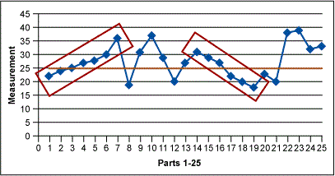

Figure 1: Run Chart – Trends Example

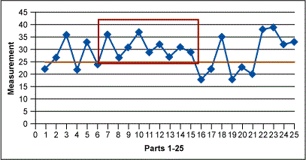

Figure 2: Run Chart – Shifts Example

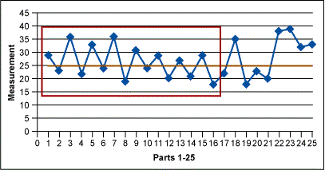

Figure 3: Run Chart – Alternating Example

**Pitfalls to Avoid**

The most common ways to misinterpret run charts are 1) to conclude that some trend or cycle exists, when in fact what is being seen is normal process variation (every process will show some variation), or 2) not to recognize a trend or cycle when it does exist. People are generally less aware that they are making the first type of error; they are tampering with a process that is behaving normally.3 In order to avoid mistakes, use the following guidelines for successful run chart interpretation:

1. Look at data representing a long enough period of time so that a “usual” range of variation is experienced. (This requires some process knowledge.)
2. Is the recent data within the usual range of variation?
3. Is there a cyclical pattern? Weekly? Monthly? Yearly?
4. Draw a best-fit trend line from the beginning to the end of the data on the run chart. If the line is approximately horizontal, then the mean of the process can be considered stationary over this time interval. If not, then the process mean is considered nonstationary, or unstable. Drawing this inference requires sufficient data, usually 50 or more observations (i.e., two points are not sufficient).

The run chart is a simple and effective improvement tool. It is not a replacement for the Shewhart control charts but it is an easy-to-use tool for identifying process variation that you can add to your continuous improvement [toolbox](https://www.isixsigma.com/tools-templates/).